 | MINISTRY OF EDUCATION AND TRAINING

FPT UNIVERSITY
Capstone Project Document
Gas selling support system

Report 1: Introduction
GSS Team
Group Member | Nguyễn Xuân Quyết 00818  Nguyễn Đức Vượng 01067  Đinh Nho Hào 00985  Nguyễn Huy Tuấn 00986  Lê Thế Đại Dương 01098
Supervisor | Mr. Phan Duy Hùng
Capstone Project code | GSS_v1.0

- Hanoi, May 1st 2012 -

The Table of Contents

1. Introduction 3
1.1. Project information 3
1.2. Purpose 3
1.3. Background 4
2. Literature review 4
3. Proposal 7
3.1. Initial idea 7
3.2. Main function 7
4. Risks 8
4.1. Human Resource 8
4.2. Time 8
4.3. Communication 9
4.4. Technical 9
5. Reference 9

Introduction

Project information
Project name: Gas selling support system
Project code: GSS
Product type: devices and application
Timeline: From May 7th 2012 to Sep 2012

Purpose
This project is registered and implemented as a capstone project for the team members. The purpose of this project is to fulfill the requirements from FPT University studying program and make a system that can be traded. Besides, this is the change for us to research, study, and work together on a project.

Background
The telephone is a device that is used to transmit and receive sound, most commonly speech between two people. It has become one of the most common household items today. Most of the telephones operate by transmitting electric signals over some kind of network. The telephone network allows the phone user to communicate with the party. In other hand, they can order product by telephone. It is one of selling trends today. This is the reason that we need more and more system to support ordering by telephone better.
Nowadays, shops or agencies always want to have a system which can support to manage and serve customer. Managing data by computer, receiving order through telephone or delivering product to customer become more popular. Hence, managing information of target customer, number and quality of product and connecting data with orders of customer become necessary. Using phone number may be feasible with these requests.
Because in Hanoi, there is most population using telephone and most families are using gas to do the cooking. They usually order gas by telephone. In addition, gas selling agencies usually receive order through telephone and manage information by computer. There are the grounds for connecting telephone with data in computer, whereby, identifying, supporting to serve customer through telephone by the best way.

Literature review
In Hanoi, although there are a lot of gas selling shops or agencies but there is little gas selling support system by telephone. A famous system is Petrogas system.
Petrogas system has been developed since 2007 by Ha The Tuan. It is fully integrated features for the gas selling shop such as manage data of customer, manage finance or manage telephone calls…
Some features of Petrogas:
+) Display phone number when the call come in, display information of customer such as name, address, product they buy, dept, map…
+) Print been with map
+) Manage information of customer
+) Manage gas business activities such as statistic order, profit, product in store…
+) Search data quickly

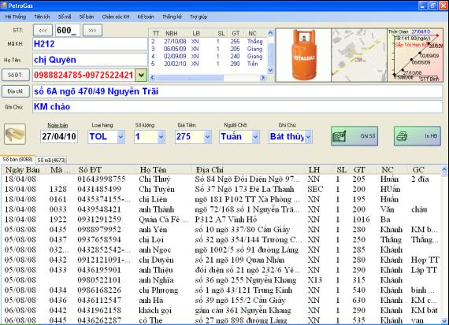

Figure 1.1: Petrolgas system

Nowadays, Petrolgas system has extended and developed. It is integrated more product, and is developed into different versions. It has more features, support more products. GDM-GAS system is one of them. It supports for gas and water selling shop or agencies and it is sold for 4 million VND depend feature of deferent versions.
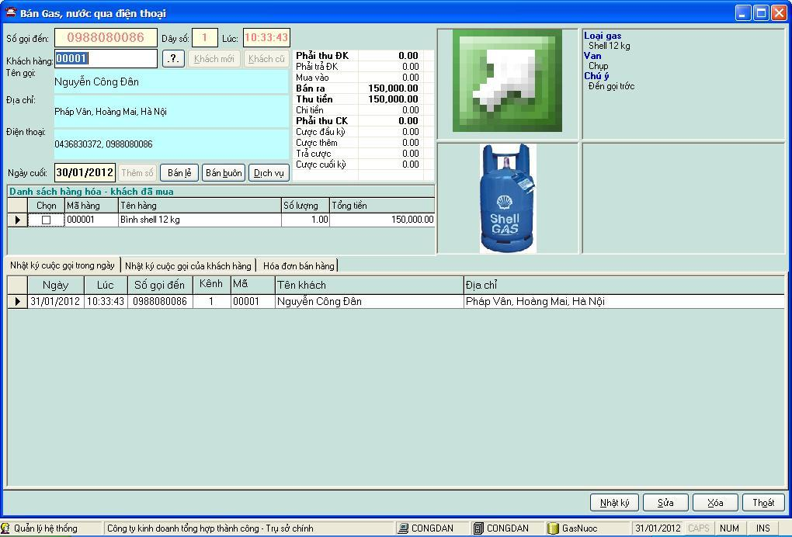
Figure 1.2: GDM-GAS-03 system

Conclusion: In fact, in Hanoi, there are a lot of gas selling shops or agencies but a little shop know and use this type system. So, we can develop a system with some features, simpler and lower price. Because there is less competition so this is potential market which we can exploit.

Proposal

Initial idea
According to a statistic, gas consuming in Hanoi is very high. Generally, most families usually use gas to do the cooking. When they are out of gas, they will call for gas selling agencies to order a new gas tank. Most orders of gas selling agencies usually receive by telephone and information of order or information of products, finance….. used to manage on the computer. Based on this reason, we decide to build a gas support selling system by telephone number that will be deployed on Hanoi market and help user- the shop keepers to have the best services to their customer and they can manage data of products, orders, customers by this system.
Our system is developed based on Vietnamese language and integrated map of Hanoi, so it is very friendly to user and easy to use. Taking phone number and automatic loading data customers, products and orders will help to user increase quality of services to customers. In addition, our system will be integrated shortest road finding algorithm, statistic algorithm, notification which help user have the best service to their customers.
Our system also supports to log miscall to the shop, avoid missing customer. Moreover, system also supports to print map on the bill, edit, manage debt, balance, profit, monthly, quarterly statistic, etc.
Some image about our system:
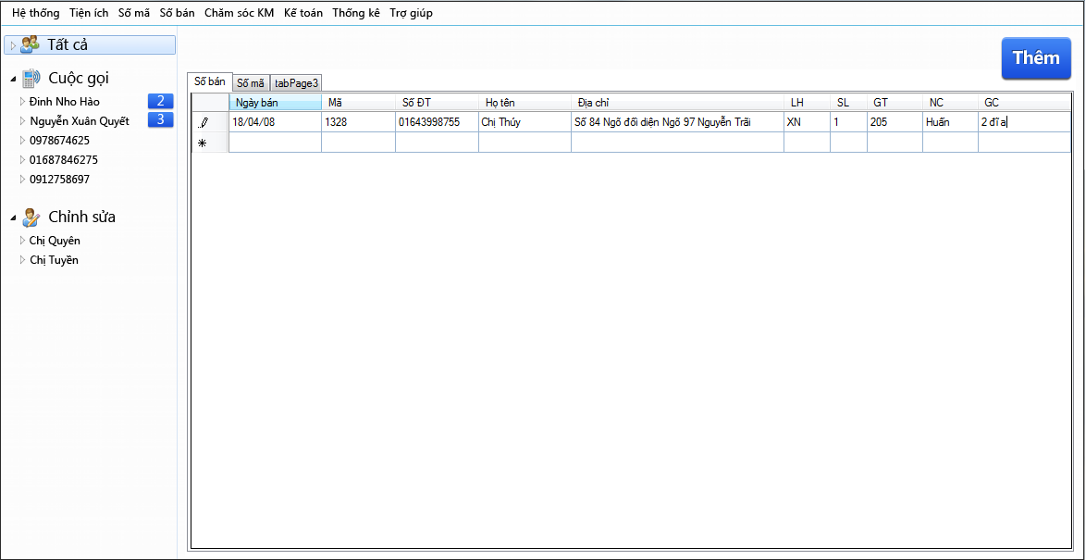
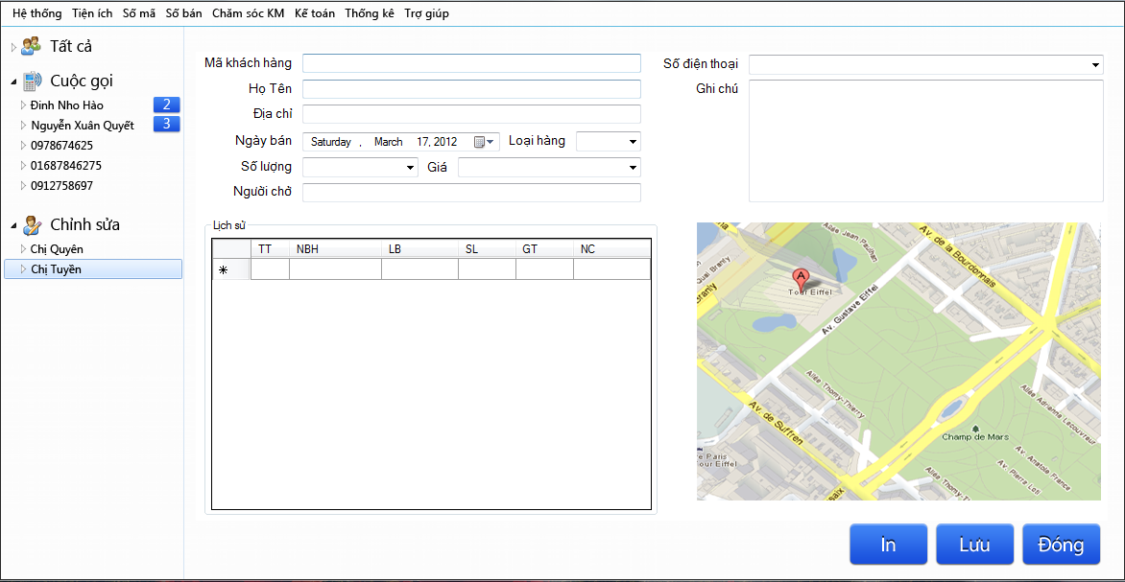

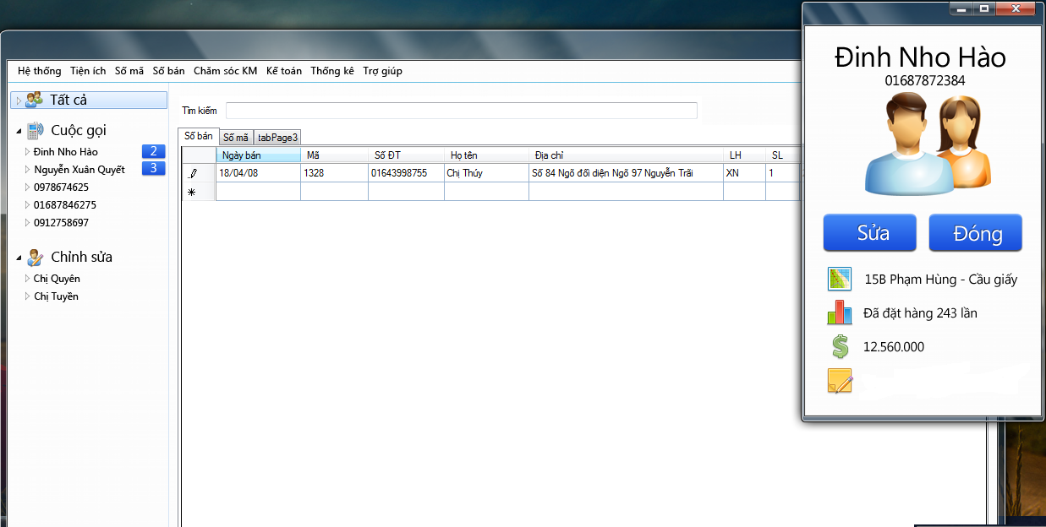

Main function
This system may have some main functions as following:
I. Embedded
Connect with telephone.
Decode and log telephone number of customer (DTMF and FSK type).
Transmit phone number to computer.
II. Software
1. Customer services
Display information of customer by phone number.
Log miscall
Statistic and calculate purchasing circle
Print bill with map
Finding shortest way
2. Management
Manage information of customer
Manage information of products
Manage import-export store
Manage profit, turnover and products by month or quarter
Manage business activities: debt, report, discount, promotion…

Risks
Risk management is an important factor that effects on the success of project. Aware of this thing, our group has found out some risks could be happened

Hardware
In fact, few embedded project finish on time. Why? Because risks embedded systems suffer from real-time and hardware integration issues. This is big problem with us. We must spend a lot of time for studying hardware, demo and testing. Ordering hardware also will take us a lot of time and money.

Testing
Developing embedded systems and information systems at the same time make us to meet difficulties with testing. To ensure to associate hardware and software take us a lot of time and have high risk. Moreover, testing embedded system demand high accuracy and has a lot of experience. This is a big problem with us.

Human Resource
Because we need to learn about management human resource so assigning the task will meet difficulties. This is the reason of delaying plan. Besides, we have some problem such as: the group may have much conflict due to different personalities, instead of complementing and balancing each other.

Time
We only have 3 months to complete project. It’s truly pressure to our group. Because during this time, team members have to study new subjects, plan, code, prepare document and test. So, assigning the task for each member and scheduling must be reasonable. This problem may affect to work’s quality.

Communication
Because in that time we could not work together in a common space, and we don’t often meet together so, transmission of information meet difficulties. Our members communicate through email, yahoo, Skype and phone. The transmission of information indirectly can cause misunderstandings and decrease rate of progress and quality of project.

Technical
First, we have to spend amount of time to research project management, software engineering process. Therefore, it gets hard in creating plan and keeping deadline.
Secondly, designing is the big problem with us. If we have a good design, we will assign the task reasonable, increase quality project and save time and money. This could be the obstacle to the success of project.
Final, we need to learn about using source code technical, making milestone, making coding convention….

Reference

“What is caller ID“

Available at: http://en.wikipedia.org/wiki/Caller_ID

“PetroGas CallerID 3.0”
Available at: http://hathetuan.com/

“GDM-GAS full”
Available at: http://www.vnbis.com.vn/web/product-55-Phan-mem-quan-ly-kinh-doanh-gas.html

